
Charity no; 1108111

MIDNIGHT MARATHON AT TEGG’S NOSE SATURDAY, 20th JUNE, 2015
MIDSUMMER MADNESS

PARTICIPANT/ TEAM NAME; …………………………………………………………………………….
ADDITIONAL CHALLENGE; ………………………………………………………………………………………………………….
NAME OF SPONSOR | CONTACT ADDRESS/ TEL NO | AMOUNT | PAID
PLEASE COLLECT IN ALL YOUR PLEDGES AND RETURN TO WINDYWAY BY 10TH JULY |  | TOTAL

Please turn over for instructions and registration details
Take care not to cut off the bottom of the table above when registering
Postal address: Windyway Kennels, Buxton Old Rd, Macclesfield, Cheshire. SK11 0AP

MIDSUMMER MADNESS, 2015

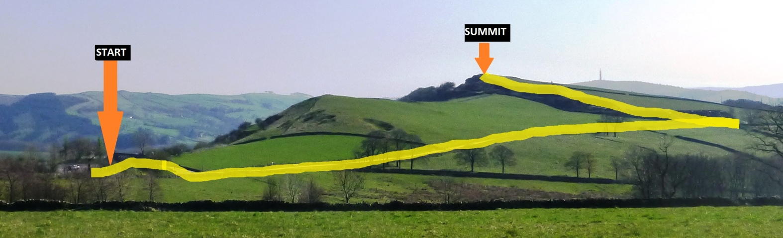
The Midsummer Madness Midnight Marathon will take place at Tegg’s Nose Country Park on the night of Saturday, 20TH June, 2015, from 11.15 pm.
We need 26 individuals or teams to come and join us in walking to the summit of Teggs Nose and back (total 1 mile) so that we achieve a marathon distance in total. Teams must have a leader.
Dogs (especially Windyway rescues) are positively encouraged but will have to stay on leads as there will be lots of them and it will be dark.
We will all walk together following the same route and every participant will need a torch and strong footwear as the path is on a track then rough hillside.
Participants need to be be physically fit and anyone below the age of 16 must have a parent present.
Meet at Tegg’s Nose Visitor Centre (parking fee waived) at 11.15 – we will set off at 11.30 so that we will be on the summit at midnight (slow pace anticipated). Bring a picnic for the midnight feast on the summit (if the weather is bad we can have it back at the visitor centre after the walk)
Everyone is invited to add an individual element of challenge to their 1 mile walk, for example going in fancy dress, performing a ‘turn’ at the picnic, etc – you decide!
Please return the registration below to Sally at Windyway by 13th June to book your place.
There is no registration fee but we would like each participant or team to aim for a minimum of £50 in sponsorship.
………………………………………………………………………………………………………………………………………………………………….…
Please register me to participate in the Midsummer Madness Midnight Marathon on 20th June, 2015
Name ……………………............................... Additional challenge (optional)…………….…………………………………………….
Address and tel no ……………………………………………………………...............................................................................................
………………………………………………………………………………………………………………………………………………………………………...
I am participating as * an individual / part of a team
Team name and team leader ……………………………………………………………………………………………………………….
I confirm that I have read and understood the conditions for taking part and hereby state that I will follow all instructions and abide by any decisions made by the organisers on the day.
Signed; ……………………………………………………………………………… * delete as appropriate

