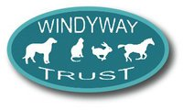
Charity no; 1108111

SPONSORED ABSEIL AT TEGG’S NOSE SATURDAY, 21ST JUNE, 2014
MIDSUMMER MADNESS

PARTICIPANT’S NAME; ………………………………………………………………………..
NAME OF SPONSOR | CONTACT ADDRESS/ TEL NO | AMOUNT | PAID
PLEASE COLLECT IN ALL YOUR PLEDGES AND RETURN TO WINDYWAY BY 10TH JULY |  | TOTAL

Please turn over for instructions and registration details
Take care not to cut off the bottom of the table above when registering

MIDSUMMER MADNESS, 2014

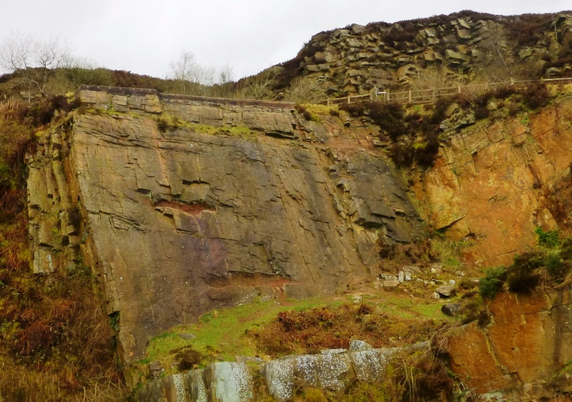
The sponsored abseil will take place at Tegg’s Nose quarry on 21st June, 2014, from 6.30 pm.
It is a relatively short one as abseils go and therefore suitable for first timers.
It will be supervised by Andi Turner ( MIA, MLS, SPA ) and all necessary equipment will be provided.
Participants must be physically fit and anyone below the age of 16 needs to have a parent present.
Participants may bring family and friends along to support but they will be required to stay at the bottom of the rock face. Anyone wishing it may have someone abseil alongside them to provide further instruction, encouragement and reassurance.
Bring a picnic to enjoy while watching the other participants and waiting your turn!
(but don’t consume alcohol before your abseil)
The organisers reserve the right to prevent any participant from abseiling.
Meet at Tegg’s Nose Visitor Centre (parking fee applies) at 6 pm for the walk to the quarry.

Please return the registration below to Sally Wilson at Windyway by to book your place. There is no registration fee but we would like participants to aim for a minimum of £50 in sponsorship.

………………………………………………………………………………………………………………………………………………………………….…
Please register me to participate in the sponsored abseil for Windyway Trust on 21/06/2014
Name, age, address and tel no (please print clearly) ….……………………………………………………………………………
…………………………………………………………………………………………………………………………………………………………………………
Emergency contact (name, address, relationship to participant, telephone no) ……………………………………….
…………………………………………………………………………………………………………………………………………………………………………
…………………………………………………………………………………………………………………………………………………………………………
I confirm that I have read and understood the conditions for taking part and hereby state that I will follow all instructions and abide by any decisions made by the organisers on the day.
Signed ……………………………………………. Signature of parent for under 18’s ………………………………………………

